
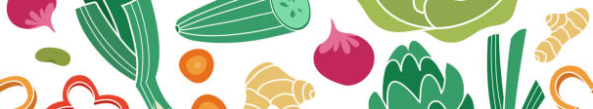

RECIPE 1: Chinese Lettuce Wraps
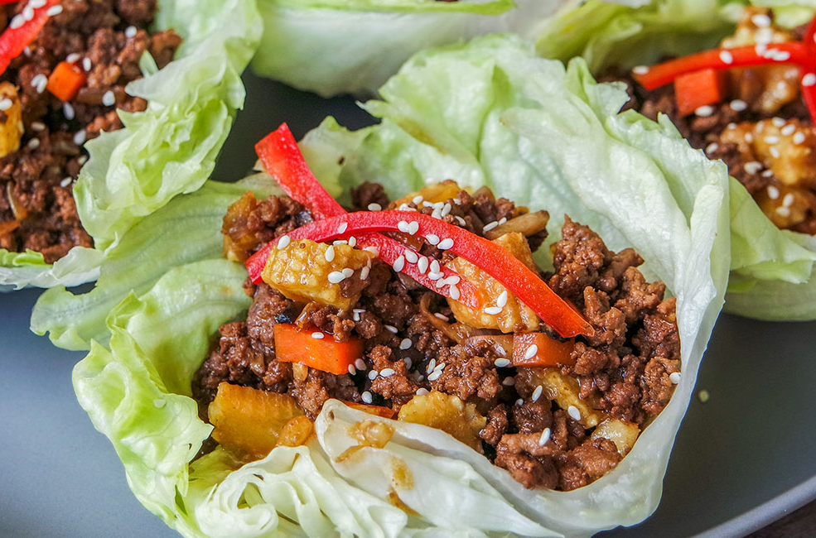
Total Time: 25 minutes | Yield: 8 servings

EQUIPMENT  - Skillet or wok  - Cutting board  - Chef’s knife  - Can opener  - Measuring spoons  - Grater  - Small bowl  - Slotted spoon  - Cooking Spoon  - Fork  - Vegetable peeler | INGREDIENTS  - 1.5 lbs. ground beef (90% lean or leaner)  - can substitute with 2 Cups of riced cauliflower; if so, you will also need 2 Tbsp. olive oil  - ½ yellow onion, diced  - 2 cloves of garlic, minced  - 1 Tbsp. fresh ginger, finely chopped or grated  - 1 large carrot, diced or grated  - 5 oz. white mushrooms, diced  - 8 oz. canned diced water chestnuts  - 15 oz. canned baby corn, chopped  - 1 ½ Tbsp. dark soy sauce (or regular soy sauce)  - 1 Tbsp. Chinese black vinegar (or rice wine vinegar)  - 2 Tbsp. hoisin sauce  - 1 Tbsp. cornstarch  - 1 head of iceberg lettuce or Bibb lettuce  - Pepper to taste  - Sesame seeds to garnish (optional)  - Cilantro to garnish (optional)  - Sriracha (optional)
INSTRUCTIONS

- Heat a large skillet or wok over HIGH heat until hot. Add ground beef cooking 8 to 10 minutes, breaking into crumbles, and stirring occasionally. Use a slotted spoon to remove beef from the pan. Discard ½ of the fat drippings.
  - If using cauliflower rice: Heat skillet or wok over MEDIUM heat, add olive oil and then proceed to step 2.

- Add onions, garlic, and ginger to the pan. Cook, stirring frequently until the onions are starting to brown on the edges. Then, add beef back into the pan.
  - If using cauliflower rice: add the 2 Cups cauliflower rice here :)

- Add carrot and mushrooms and cook for 2 minutes, stirring regularly.

- Add water chestnuts, baby corn, soy, vinegar, and hoisin sauce. Stir and cook for 2 minutes.

- In a small bowl, dissolve the cornstarch in enough cold water to cover it (about 1 Tbsp.) and whisk together until it thickens. Add the cornstarch slurry to the beef mixture. Cook for 2-3 minutes, stirring frequently until the mixture thickens.

- Prepare the iceberg lettuce cups by slicing down on either side of the stem, then carefully separating out the cups by hand. Lettuce cups can be one or two layers thick based on your preference.

- Spoon the beef mixture into the lettuce cups and sprinkle with sesame seeds, cilantro and sriracha as desired. Serve immediately.

** Because nearly all these sauces have salt in them, we prefer not to add any extra salt to the recipe

** If you don’t have pre-made cauliflower rice, use these steps below to make your own!
- Clean and cut cauliflower and cut big florets
- Blanch the florets in hot, boiling water and give them an ice bath
- Drain florets in a colander and allow them to dry.
- Process in a food processor until florets resemble rice or couscous

Nutrition Information per Serving:
360 Calories; 10.6 g; Total Fat (3.9 g Saturated Fat; 4.2 g Monounsaturated Fat); 69.8 mg Cholesterol; 847 mg Sodium; 34 g Total Carbohydrate; 7.4 g Dietary Fiber; 36 g Protein; 4.8 mg Iron; 693 mg Potassium; 0.6 mg Vitamin B6; 2.2 mcg Vitamin B12; 6.1 mg Zinc.

Adapted from this original recipe: https://beeflovingtexans.com/recipe/beef-san-choy-bao-chinese-lettuce-cups

RECIPE 2: Spicy White Bean Dip with Wonton Chips

Total Time: 20 minutes | Yield: 4 servings

EQUIPMENT  - Blender or food processor  - Cutting board  - Chef’s knife  - Can opener  - Measuring spoons  - Baking sheet  - Aluminum foil | INGREDIENTS  - 15 oz canned white beans (rinsed) - we prefer cannellini beans but you can also use canned chickpeas  - 2 tablespoons olive oil  - 1 teaspoon sesame oil  - 2 teaspoons low sodium soy sauce  - 1-2 tablespoon sriracha sauce (we prefer 2 Tbsp)  - 1 clove garlic, minced  - 1 teaspoon curry powder  - 1/2 tablespoon lime juice  - 1/2 tablespoon orange juice (ok to use 1 tablespoon lime juice and omit OJ)  - 2 tablespoons water  - Cilantro, chopped (for garnish)  - 12 Wonton wrappers  - Spray cooking oil  - salt

INSTRUCTIONS

- Preheat the oven to 400°F, line the baking sheet with aluminum foil and lightly spray it with cooking oil.

- Cut each wonton wrapper diagonally into 2 triangles. Place them in a single layer leaving some space between them.

- Lightly spray some oil on wontons and sprinkle some salt. Bake for a total of 6-8 mins turning half way through until crispy and golden.

- While wonton chips bake, make dip by combining all ingredients (white beans, olive oil, sesame oil, soy sauce, sriracha sauce, garlic, curry powder, water, and lime juice) into a blender (or food processor).

- Blend until smooth. If the dip is too thick, add additional olive oil. Taste the dip and add additional seasonings if desired.

- Serve with wonton chips

** Can also serve with raw veggies, crackers or chips

Nutrition Information per Serving:
360 Calories; 10.6 g; Total Fat (3.9 g Saturated Fat; 4.2 g Monounsaturated Fat); 69.8 mg Cholesterol; 847 mg Sodium; 34 g Total Carbohydrate; 7.4 g Dietary Fiber; 36 g Protein; 4.8 mg Iron; 693 mg Potassium; 0.6 mg Vitamin B6; 2.2 mcg Vitamin B12; 6.1 mg Zinc.

Adapted from this original recipe: https://whiteonricecouple.com/spicy-white-bean-dip

