March 18, 2024 Faculty Senate Meeting Minutes
Claudia Lucchinetti – Dean’s Update
Match Day:
- Dell Med had a 100% match rate. The national average is 95.3%. This is the 3rd time in 5 years at Dell Med that 100% match has happened. 42% of graduating students are staying in Texas.
Commencement:
- Dell Med commencement is May 9. Leadership would like as many faculty to attend, specifically tenured faculty. The University commencement is May 11 7:30 PM at Darrell K Royal-Texas Memorial Stadium. President Hartzell has requested good representation of faculty to attend this ceremony.
  - RSVP: scott.ertresvaag@austin.utexas.edu if you plan to attend
  - Regalia needs (Cap and gown): RSVP to dellmedevents@austin.utexas.edu,
New Leadership:
- Gregory Wallingford, MD, MBA, is the new Assistant Dean for professional Fulfillment & Well-Being.
Strategic Planning Process:
- Strategic planning is underway at Dell Medical School. Those involved want to outline goals, directions, and tactics.
- The strategic plan will be mapped to several metrics and tactics in the coming year. It is intended to represent the goals from 2024-2030. It is in alignment with the university plan but differs slightly as Dell Med is a health learning institution. There is a strong focus on the expansion of clinical practice, community impact, and research.
Faculty Senate, Save the Date – April 25, 5:30-6:30
- The Faculty Senate group will have a 1-on-1 meeting with Claudia to identify areas of high priority focus to aid in developing the strategic plan. This meeting is not for ironing out smaller details but instead to act as a landing page/space to identify areas in need of attention.
- The hope is this meeting will help strike the right balance between inspirations and practical implementation and highlight the direction Dell med wants to move toward specifically regarding expanding clinical work and research.
- The Department of Medical Education has been very active with the LCME, and Claudia wishes to highlight the work they have done.
Following Faculty Senate meeting will be June 17th @ 5:30
Sujit Iyer – Introduction of the Faculty Senate
- The Faculty Senate acts as an approval body for matters relating to the faculty at Dell Med as a whole.
- Each department has two regular members with voting privileges, and one alternate member who has voting privileges only on the occasion a regular member is unavailable to represent the Department during the vote. Each member serves a term of three years.
- The Senate members are also responsible for disseminating the information back to their departments, as well as communicating with the department on matters the Senate should be involved in.
Jonathan Macclements – Faculty bylaws update and vote
- The Faculty Senate approved the bylaws changes in November, and now the Faculty as a whole were invited to also vote. The updated bylaws were sent to all regular faculty on March 1, 2024.
- There were 5 major updates to the faculty bylaws:
  - Definition of roles, particularly executive and educational roles
  - Removal of non-function and/or non-existent committees
  - Proper specification of roles of existing committees
  - Codification of APT Committee and the new Office of Faculty Affairs
  - Standardization of operations to follow usual medical school operations
- All regular faculty who attended the meeting were eligible to vote to approve or not approve the bylaws:
  - 81% participation (50 of 61 meeting attendees voted)
    - 46/50 (92%) voted to approve
    - 0/50 voted to not approve
    - 4/50 (8%) abstained from voting
Beth Nelson – Annual Education Update
UME Updates:
- MS1 year underwent some resequencing based on student and faculty feedback. These changes will roll out in the class matriculating this summer.
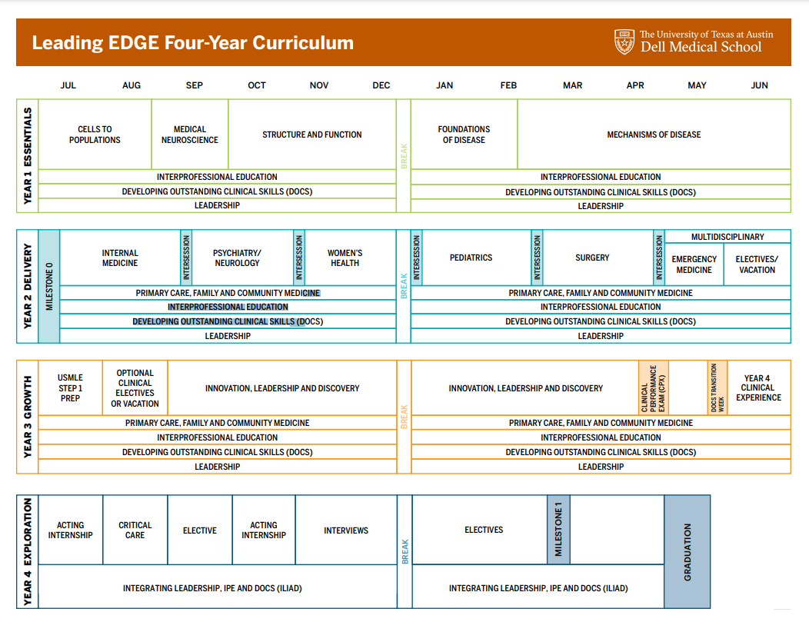
- There will be more flexibility for MS4 year students. Dell Med does not have residency options in all specialties, ENT as an example, so rules have changed to allow students to enter an internship not represented at Dell Med and still meet graduation requirements.

- A 5th cohort of students will be graduating in May.
- Dell Med currently offers 8 dual degree masters programs and 3 distinctions.
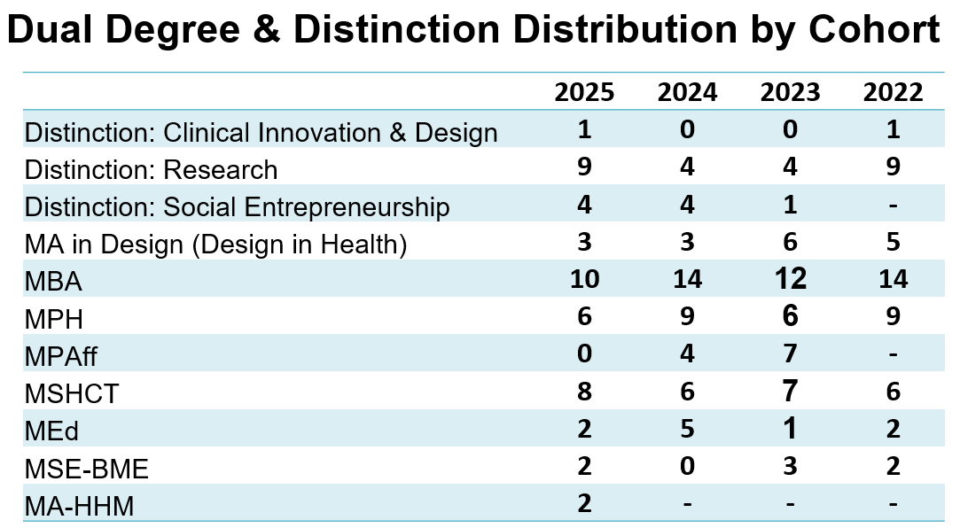
- This is third year Dell Med graduates did not have to utilize SOAP.
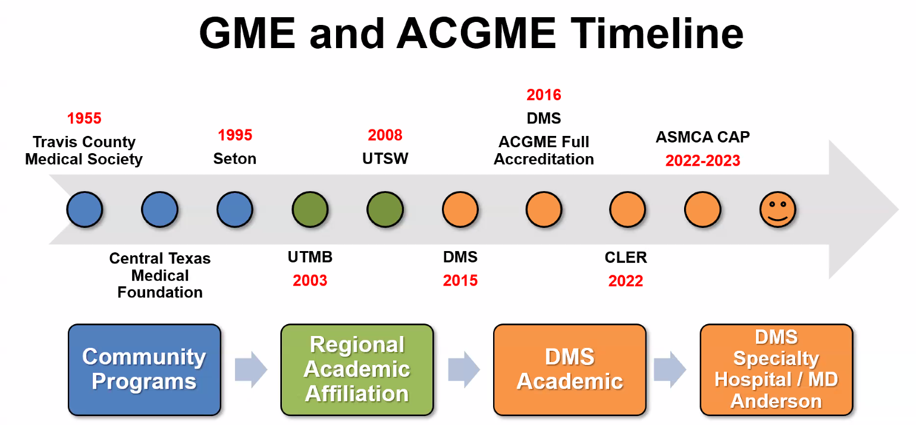
GME Updates

- Dell Med has added 16 new fellowship and 5 new residencies since its first year.
- Dell Med has around 460 new trainees when accounting for this year’s match results. Currently, there are 84 fellows and 364 residents.
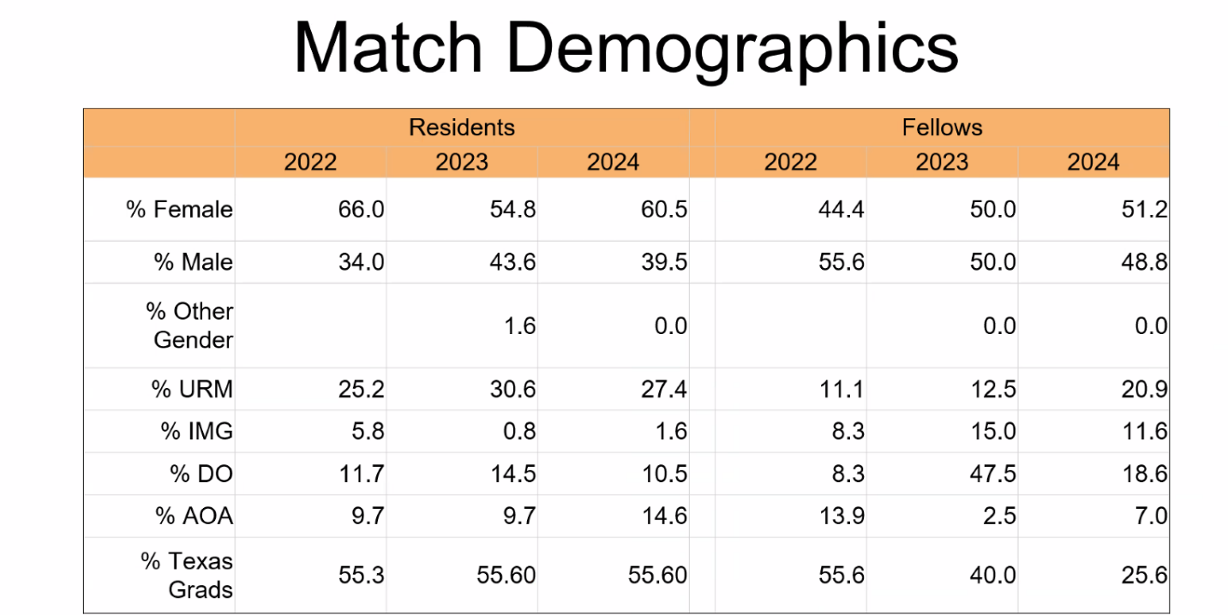
 | Residents |  |  |  | Fellows
 | 2022 | 2023 | 2024 |  | 2022 | 2023 | 2024
Step 1 | 234.3 | 234.7 | 237.6 |  | 226.0 | 222.6 | 231.2
Step 2 | 245.8 | 249.1 | 248.9 |  | 238.8 | 234.5 | 243.1
Step 3 | 227.9 | 228.5 | 229.0 |  | 223.6 | 219.9 | 227.4

CME Reaccreditation
- There are 18,201 participants in CME with a staff of only ~2.3.
- CME is becoming more regulated and stringent.
  - If anyone is interested in organizing a CME group, best practice is to reach out as soon as possible and understand that due to limited staffing, they are at capacity currently. There is ongoing effort to increase staffing.
Ongoing Med Ed Issues
- Vice Dean search is currently underway. 4 candidates have been identified, and one is in Austin now interviewing for the position.
- GMEC Professional Development Committee distributed a needs assessment survey for faculty development. Please respond if you have not already. The deadline has been extended for another week to increase participation.

Elizabeth Matsui – New Professional-Track Title Series and Promotion Information
Clinical Professor Title Series
- The Intranet site has all of this information posted for easy access.
- The non-tenure track has been renamed the Professional-Track.
  - There is now a new title under the Professional-Track called the Clinical Professor title series. It was added to ensure a path for advancement for a faculty member who has a heavier clinical load.
Promotion Timeline
- During your 6th year in rank, you are evaluated for your readiness for promotion.
  - If you are tenure-track, you MUST go up for promotion.
  - If you are professional-track (formerly non-tenure track), you are NOT required to go up for promotion during your 7th year in current rank.
  - Promotion Timeline Resources
    - Tracking Your Progress Towards Promotion
    - Preparing Your CV for Promotion
    - Professional-Track Faculty Promotion Policy
    - Tenure-Track Faculty Promotion and Tenure Policy
    - DMS Promotion Timeline 2024-2025
    - Clinical Professor Title Series and Professor Title Series Comparison Table
    - Professional-Track Faculty Summary of Dossier Preparation
- The Office of Faculty Academic Affairs hosts office hours for faculty requesting guidance on their progress toward promotion, faculty development, and more. These are held online via Zoom.
  - If you are unable to attend any of the scheduled office hours or workshop sessions, please email DellMedFacultyAffairs@austin.utexas.edu to schedule an appointment.
Taylor Hutton – CAMP and Specialty Advisors
Taylor manages the career advising programs here at Dell. These programs launched in the fall and span across all 4 years of a student’s time in medical school.
Career Advising and Mentoring Program (C.A.M.P.) Cerebrum site
C.A.M.P. Specialty Advisors & Alumni Mentors page

- Career Advising and Mentoring Program (CAMP)
  - Specialty Advising Expectations
    - Attend training – training sessions coming up in late May.
    - Be available for two specialty fairs per year, one in the spring and one in the fall.
      - For students to get an introduction into a specialty they may be interested in.
    - Be available to meet with and support the student interest group in your field, as needed.
    - Pre-lottery advising on 4th-year schedule course selections of students in your field that may name you as their primary advisor.
    - Meet with and advise any interested students MS1-MS4.
      - Students are informed the specialty advisors are available to them at any point in their medical school career.
  - If you are interested in joining, email taylor.hutton@austin.utexas.edu.

